RESULTS FROM ORBCOMM ICE BUOY DEPLOYMENTS

David Meldrum¹, Duncan Mercer¹, Oli Peppe¹ and Martin Doble²

¹ Scottish Association for Marine Science (SAMS), Dunstaffnage, Oban, Scotland
² Scott Polar Research Institute (SPRI), Cambridge, England

ABSTRACT

Last year we described the development and deployment of novel ice drifters in the marginal ice zone of the Weddell Sea. Since then, further deployments have been made in the Odden region of the Greenland Sea. The buoys carried vertical accelerometers for in-situ wave spectral analysis, as well as meteorological and SST sensors. Both deployments have relied on Orbcomm as their primary satellite communications system. In addition to detailing our practical experience in the use of Orbcomm at high latitudes, we will present some of the scientific results regarding ice deformation which are emerging from the our studies of the buoy tracks and sensor data.

INTRODUCTION

Sea ice influences the Earth’s climate in many ways: its high albedo affects the planet’s heat budget; its thermal insulation controls heat and mass fluxes between the atmosphere and the polar oceans, and its role in destabilising the water column through brine rejection may drive deep convection. In addition, variations in the seasonal pattern of sea ice distribution are likely to be sensitive indicators of changes in the heat content of the upper ocean, itself a key marker for climatic change (Wadhams, 1991). However, the processes governing ice formation, especially in the outer part of the pack, are not well understood. Moreover, young ice is not well imaged by satellites, thus placing increased reliance on in situ studies such as the ones described here.

In our Antarctic study, called STiMPI (Short Timescale Motion of Pancake Ice) we deployed an array of drifters in the Antarctic marginal ice zone (MIZ) during the period of ice formation in the 2000 austral winter. The array was designed to measure the deformation of the young ice pack and its response to wind forcing and wave action, thus giving an insight into the mechanisms of sea ice growth, and the likely impact on regional heat and mass fluxes. The drifters incorporated wind and temperature sensors, a vertical accelerometer, a GPS receiver and Orbcomm satellite transceiver. Using techniques previously developed during the NERC Land-Ocean Interaction Study (Meldrum 1997, 1999), GPS locations were post processed to remove the major error components and yield highly accurate relative displacements and velocities. A totally independent meteorological package (a Metocean SVP-B, minus its drogue, but complete with its own batteries and Argos satellite transmitter) was installed to transmit weather data. These data have been disseminated globally in near real time via the Global Telecommunication System (GTS) for use by national meteorological centres. Data distribution continued after the drifters left the ice and entered the Antarctic Circumpolar Current (ACC) and the open waters of the Southern Ocean.

In the Arctic deployment, two buoys of similar construction, but not carrying SVP-Bs, were deployed in the Odden ice tongue in the late 2001 winter as part of an EU-funded study into the role of sea ice in triggering deep convection in the North Atlantic.

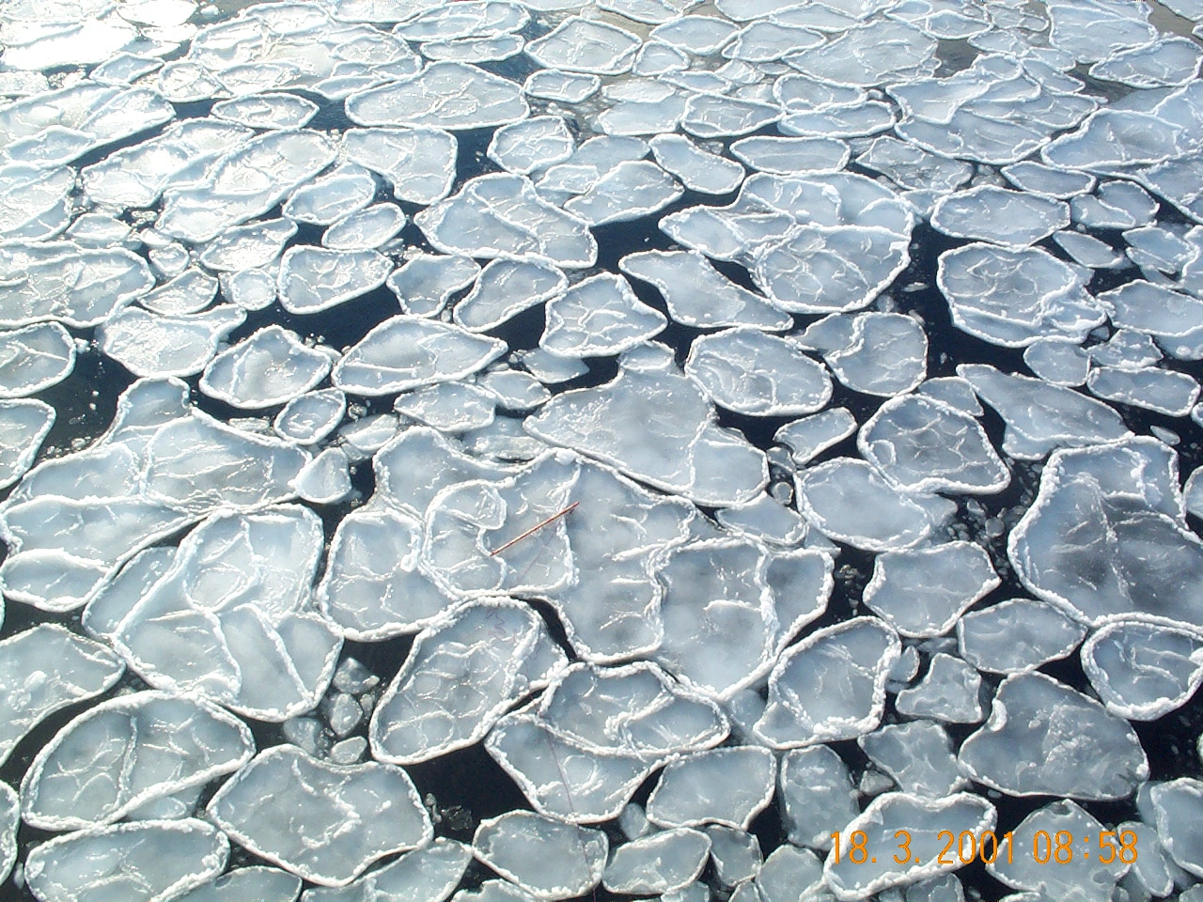
Figure 1. Pancake ice in a young icefield. The raised edges are caused by repeated collisions between cakes of frazil ice.

SEA ICE FORMATION

The general mechanism of sea ice formation is as follows. As the sea surface cools and freezing begins as a suspension of small unconsolidated crystals, called frazil or grease ice, which cannot congeal to form a coherent young ice sheet because of wave action. Cyclic compression in the ocean wave field causes the frazil, as it grows denser, to clump together into small cakes, which acquire raised rims from the pumping of frazil on to their edges during further collisions. This is pancake ice (Figure 1). Initially the cakes are only a few cm in diameter, but grow in size and thickness with distance from the ice edge, until they reach 3-5 m in diameter and a thickness of 50 cm (Wadhams, 1991). As the penetrating wave field moves through this ice edge pancake zone it gradually loses energy, but (in the case of the Weddell Sea) only after some 270 km are the waves damped enough to allow the pancakes to freeze together to form a continuous ice sheet (Wadhams et al, 1987). This process of ice sheet formation is called the frazil-pancake cycle (Lange et al, 1989) and is responsible for a significant percentage of ice production in the Antarctic. The Antarctic pack expands until September-October, followed by retreat and break-up due to warmer temperatures and the effects of the wave field.

The nature of pancake icefields makes study of their detailed motion very difficult. The small size of the cakes and their constantly changing aggregations (Wadhams et al, 1996) precludes the use of satellite feature-tracking methods, such as that of Kwok et al (1998). The International Programme for Antarctic Buoys (IPAB) maintains collaboration among national groups deploying buoys on the sea ice, but all buoys currently in this programme are designed to be deployed on solid pack ice. Further, conventional satellite-tracked Argos drifters cannot resolve the short time-scales of pancake motion (Martinson and Wamser, 1990) due to long gaps between position fixes. It is possible that short time-scale alternations of convergence and divergence have important implications for overall ice production rates through exposure of new sea surface. Studies by Leppäranta and Hibler (1987), for instance, suggest that more than 25% of the energy of the strain rate invariants in sea ice may occur at periods between 0.5 and 3 hours.

USE OF SATELLITE TECHNOLOGY

The ice drifters use three different satellite systems for position determination, data telemetry and control. Two of the systems (Argos and GPS) are well proven, but the third system (Orbcomm) is relatively new and untested (Meldrum, Mercer and Peppe, 2001). The experiments were therefore designed to collect as much operational data as possible using the Orbcomm system so that our experience will allow a detailed assessment of its potential for data collection from remote locations.

Orbcomm

Orbcomm satellites consist of discs about one metre in diameter prior to deployment of solar panels and antenna, about 30 are currently operational. The A, B, C and D planes are at 45° inclination and therefore have poor coverage at high latitudes: only two satellites, in the F and G planes (70°), offer a near-polar service (Figure 2). No further launches have been announced.

The system offers both bent-pipe and store-and-forward two-way messaging capabilities, operating in the VHF (138-148 MHz) band. User terminals are known as ‘Subscriber Communicators’ (SCs). The message structure currently consists of packets transmitted at 2400 bps (scheduled to rise to 4800 bps), and coverage is global and near-continuous between the polar circles. Messages are acknowledged by the system when correctly received and delivered to a user-nominated mailbox.
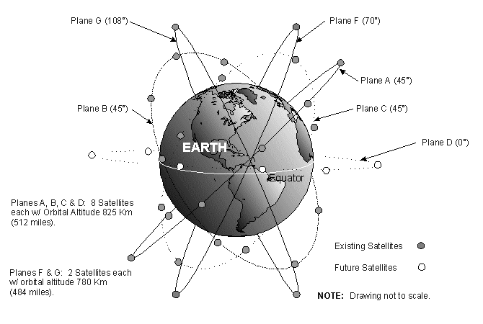
Figure 2. Orbital planes for the Orbcomm constellation. The D-plane satellites have in fact been placed in an inclined orbit. At present, only the three operational satellites in the F and G planes give polar coverage.
The limitations on the store-and-forward mode messages (known as globalgrams) have become apparent, with SC originated messages limited to 229 bytes and SC terminated messages limited to 182 bytes. Each SC can theoretically have a maximum of 16 globalgrams stored on each satellite. Currently, satellites will not accept or process globalgrams when in view of a ground (‘gateway’) station. As messages have to be designated as globalgrams or bent-pipe by the SC at the moment of origination, this presently limits the flexibility of the system to adapt to different coverage situations. Work-arounds do, however, exist, and it is expected that the next generation of SCs will be able to adapt more readily to changes in satellite communications mode.

Currently subscription costs within Europe are on a fixed cost per unit with two bands of usage (above and below 4kbytes per month with a typical monthly rate for the higher band being $70). A fully metered billing system based on users’ actual data throughput was to have been implemented in July 2000 but was postponed, officially due to technical problems. If this billing system is implemented with the planned charges ($6/kbyte) then it will result in a massive increase in airtime costs for any user with data rates over 0.5 kbytes/day. Metered billing is apparently implemented outside Europe.

Orbcomm have been suffering financial difficulties, and filed for ‘Chapter 11’ bankruptcy protection in September 2000. The outstanding debts are believed to stem largely from the system rollout phase, with net running costs being of much smaller concern. Industry opinion is that Orbcomm will prevail, largely because of the commitment of many third-party equipment and system manufacturers to the success of the system, and evidence of increasing service take-up by a diverse range of customers.

ICE DRIFTER DESIGN

The buoy was designed to mimic as closely as practicable the properties of the pancakes being studied. SAMS and SPRI have already built such a buoy in fibreglass for the Odden region of the Greenland Sea (Meldrum, 1998). Ice conditions in the Antarctic, however, demand a rather different approach since, unlike the Odden, Antarctic pancakes consolidate into large ice sheets that exert a much greater force on the buoy. The design must withstand repeated impacts with pancakes and larger floes, as well as static pressure from convergent ice conditions. The buoy was therefore fabricated from 3 mm thick stainless steel sheet, with sensors and antennae supported by a stainless steel tripod. The design also features sloping sides, allowing the buoy to rise up and avoid being crushed between ice floes.

The sensor fit included three Betatherm thermistors (narrow and wide range sea temperature, air temperature), a Motorola GPS receiver (position and time), a gimballed vertical accelerometer (wave energy spectrum), a KVH fluxgate compass (buoy orientation) and an R M Young anemometer (wind speed and direction). Custom signal conditioning electronics was designed and built at SAMS to interface the analogue sensors to the processor module. For the Antarctic deployments, meteorological data (atmospheric pressure and sea surface temperature) were collected and transmitted by an entirely independent package consisting of a standard Metocean WOCE SVP-B drifter hull embedded in a well in the main hull. This had the appealing advantage of minimum engineering effort coupled to a high expectation of data integrity.

Orbcomm store-and-forward messages (‘globalgrams’) were used for both data and command strings. Sensor and status data were formatted as two globalgrams every three hours. In order to assure correct reception of the data, and to test data throughput and latency for various paths through the Orbcomm ground segment, replicate messages were interleaved in the message stack and addressed to each of the three Gateway Control Centers in the US, Brazil and Italy.

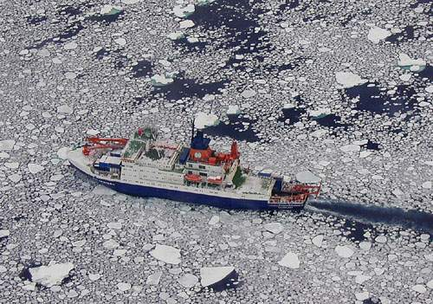
DEPLOYMENTS
Figure 3. RV Polarstern in deployment area.

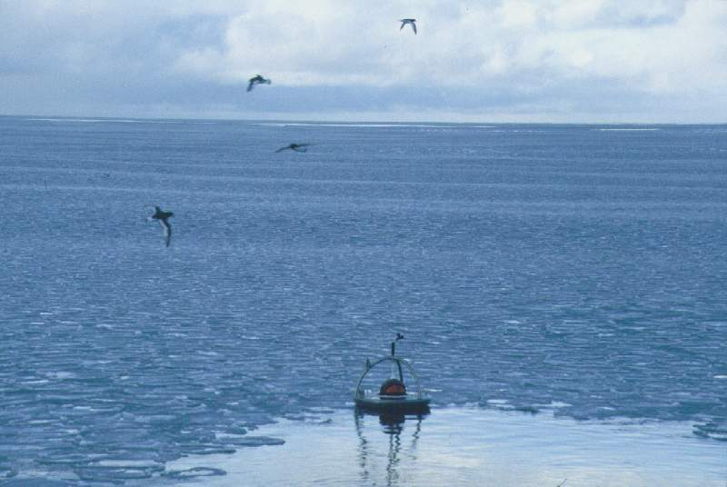
For the Antarctic study, six buoys hulls were constructed and shipped on board RV Polarstern. Simultaneously, sensor and processors units were built at and air-freighted to Cape Town. Final assembly and testing was completed on board Polarstern during the voyage south. A brief trip ashore at the Neumayer Antarctic base allowed a GPS base station to be installed for post-processing purposes. Deployments into the pancake-ice zone were successfully completed in mid April 2000 (Figures 3, 4 and 5), and meteorological data were disseminated via Argos and the GTS shortly afterwards.
Figure 4. Buoy release amongst pancake ice.

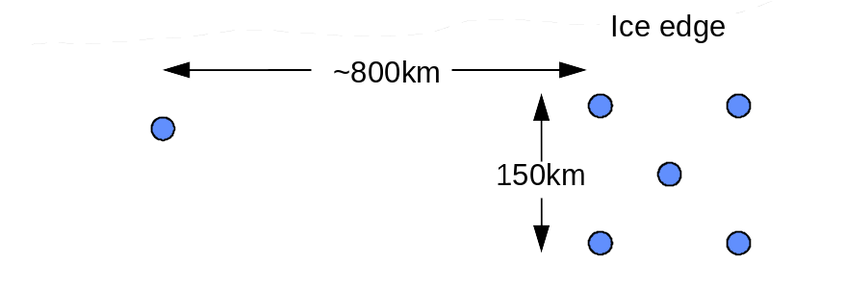
Arctic deployments were made in poor conditions from the RV Jan Mayen (Figures 6 and 7) in March 2001. Severe difficulties were encountered in communicating with the platforms, possibly because of 'hybrid mode' operation of the Orbcomm polar orbiters by the Orbcomm control centre (Figure 8). There is also some evidence that the buoys suffered occasional capsize in the unusually rough seas that persisted throughout the study period. As a result of this and the anomalously sparse ice conditions that existed in the Odden in 2001, the Arctic results will not be further discussed here.
Figure 5. Layout of the deployment array.

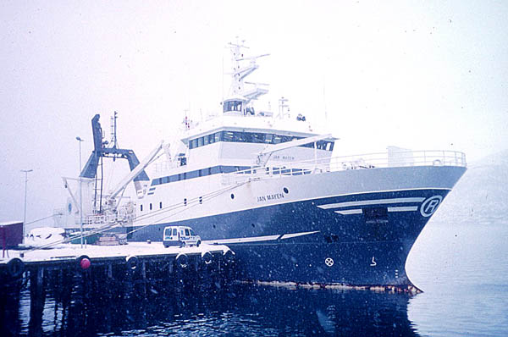
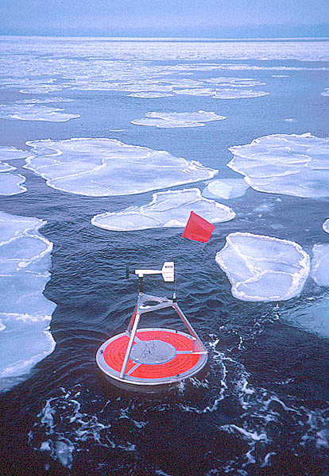
Figure 7. RV Jan Mayen.
Figure 6. Odden deployment, 2001.
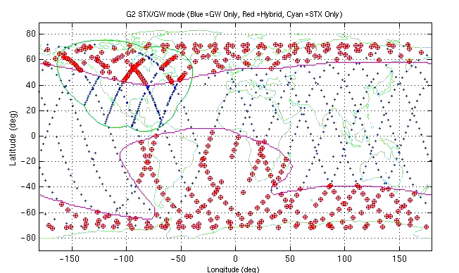
Figure 8. Geographical areas in which early Orbcomm satellites operate in hybrid mode, with reduced chance of successful communication with mobiles. Much of the South Atlantic and both polar regions are affected.

ANALYSIS OF RESULTS

Vertical accelerations and Differential Kinetic Parameters (DKPs)

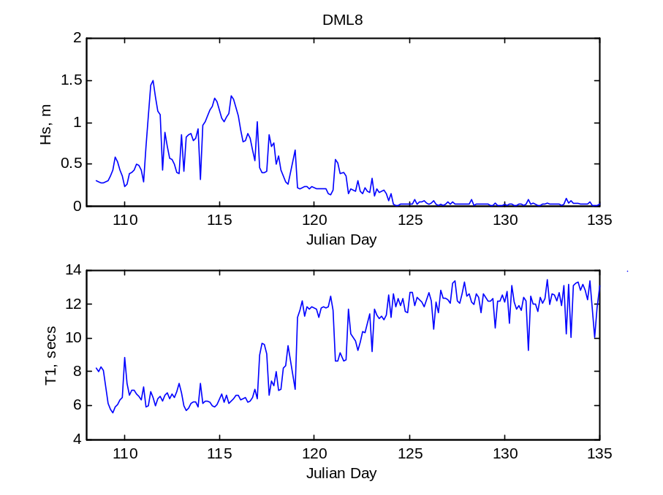
Accelerometer data were analysed to yield significant wave height and period. These data (Figure 9) clearly show the attenuation of wave amplitude and the damping of higher frequencies as the pack consolidated. Consolidation was essentially complete by day 125.
Figure 9. Changing characteristics of both significant wave height and period as consolidation progresses.

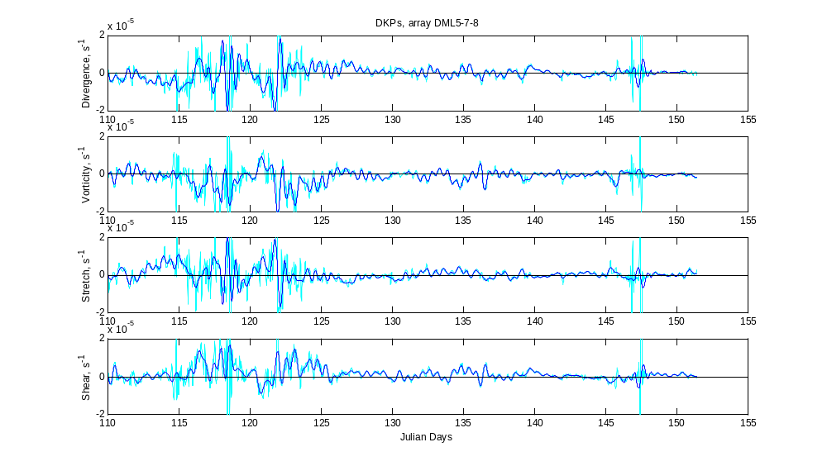
Differential GPS location data were processed to derive DKPs for the buoy array. A striking feature of the DKP timeseries (Figure 10) is a twice-daily oscillation in all parameters of approximately 0.2×10⁻⁵ s⁻¹. While spectral maxima of divergence at periods close to 12 hours have been noted (Kottmeier, 1996), this has not been seen in other parameters or in deep water areas (the Kottmeier study noted this in shelf areas near the Antarctic Peninsula, implying a tidal source to the variation). This has major implications for ice growth and increased ocean-atmosphere heat flux, as this “ice accordion” - crushing thin ice during convergent events and exposing sea surface during divergence - is a particularly efficient ice growth process at high-frequencies (Padman, 2000). The oscillation is not apparent after Day 146 and is not reflected in the wind DKPs.
Figure 10. Differential kinematic parameters for the outer ice-edge array. The ice cover consolidated from pancakes to pack ice around Day 125, which is reflected in the marked reduction of all parameters after this period. Full-resolution results are shown in cyan, with nine hour low-pass filtered results in blue. The oscillation at approximately 12 hours period is clearly shown.

Spectra over the buoy lifetimes

The time evolution of the spectra was investigated over a running 10 day period, with reference to the spectral slope (α) and the integrated power (divided by bandwidth) in high- and low-frequency regimes. Spectral slope was calculated for the spectrum (2 segment, 512 sample Welch) between 3 hour and 12 day periods, corresponding to the largely linear (in log space) portion of the curve, and is shown for all main-array buoys in Figure 11.

The spectral slopes for various buoys largely overlay, showing a trend to increasing values (i.e. a reduction in HF motion) until Day 190 with a similar-gradient decrease thereafter. This is consistent with more consolidated pack transferring energy to higher wavenumbers. The decrease after Day 190 suggests that the northward-advecting pack is becoming less constrained after this date. Values are markedly higher than quoted in the literature (0.5-1.5) Vihma, 1996) though the range of periods over which that slope was calculated is not given. Character of the V-component α is similar.

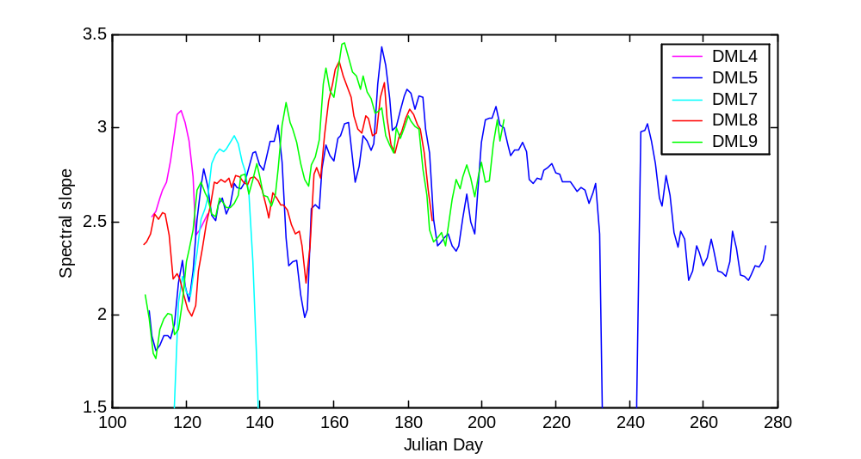
Selective Availability
Figure 11. The slope of the U-component spectra (in log-log space) over a 10 day running window, for all buoys. Slope is calculated between 3 hours and 12 day periods – the essentially linear portion of the log-log spectra.

The GPS buoy drift data divides into two types, as a result of the US Senate decision to remove the superimposed error signal (selective availability, or SA) from publicly-available positions on May 1st 2000. Prior to this date the variance of position accuracy for ‘raw’ positions was approximately 50m and this fell to 10m once SA was removed.

A differential GPS (DGPS) base station was installed at the German “Neumayer” station, enabling post-processing of the buoy positions to achieve a 10m position error variance. The correction was based on seeing the same satellites at the base and mobile stations and removing the error seen at the (known) base position from the mobile platform. The alternative method – transmitting the pseudo-ranges to each satellite from each mobile platform – was deemed too costly in transmission bandwidth. Over the period to May 1st, we were able to post-process 70% of the successful mobile fixes. The breakdown for each buoy is given in Table 1, below, and shown for actual numbers of fixes in Figure 12.

DML ID | % 20m fixes | % 100m fixes | % lost fixes
4 | 78.2 | 19.4 | 2.5
5 | 41.1 | 26.5 | 32.4
6 | 68.1 | 26.9 | 5.0
7 | 39.5 | 28.4 | 32.1
8 | 70.8 | 21.4 | 7.9
9 | 51.0 | 29.3 | 19.7
Total | 57.8 | 25.3 | 16.9

Table 1. The success of the post-processed differential GPS solutions, measured as a percentage of the expected number of fixes (72 per day x buoy duration) until the end of the SA era on May 1st 2000. DML5 and DML7 have a large number of lost fixes due to a long (non-coincident) blank period in their GPS transmissions. The total figure takes the sum of actual number of fixes, rather than the mean percentage.
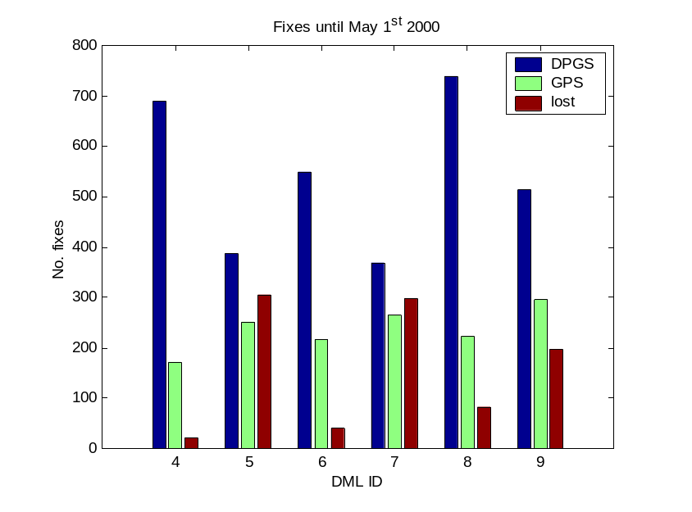
Figure 12. Number of fixes for each buoy which were successfully post-processed (blue), valid but not able to be corrected (green) and lost (red). Only fixes until the end of selective availability (1/5/00) are considered.
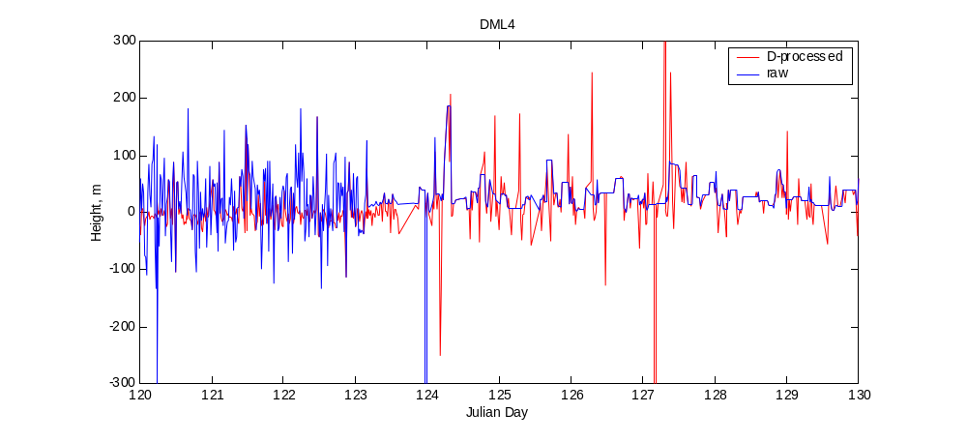
Discussions with GPS companies suggested that the accuracy of a given position in the post-SA era is better prior to DGPS post-processing than after. This is supported by plotting the height solution for the post-SA differential and raw solutions (Figure 13) and the variances of the height (Table 2). The solution for height is a good estimator of the overall position quality, though the magnitude of the height error will be greater than for the horizontal solutions. Prior to the cessation of SA (Day 123.18) the DGPS height is much less erratic than the raw solution. After this date, the raw solution is superior. We therefore use DGPS positions until the changeover at 0430Z on May 2nd 2000, and use raw GPS positions thereafter.
Figure 13. Height solutions for raw GPS (blue) and post-processed DGPS (red) DML4 positions across the selective availability boundary. The differential solution is better prior to cessation of SA (Day 123.18), but the raw solution is better after this date.

DML4 | Var during SA | Var post-SA
Raw | 3352 | 615
Differential | 846 | 2296

Table 2. Variances of the height solution for raw and differential positions prior to and after the end of SA, for buoy DML4 (the most successful in terms of DGPS corrections). Variances are similar for the pre-SA differential and post-SA raw positions (highlighted).

ACKNOWLEDGEMENTS

We gratefully acknowledge the support of the UK Natural Environment Research Council in funding this experiment through research grant GR3/12592, the UK Meteorological Office for material assistance in procuring and operating the SVP-B meteorological packages, the Alfred Wegener Institute, Bremerhaven, for logistical support aboard the RV Polarstern, Norwegian research institutes for the use of RV Jan mayen, and the UK Defence Evaluation and Research Agency for the loan of shipboard oceanographic equipment.

REFERENCES

Campbell, WJ, Josberger, EG and Mognard, NM, 1994. Southern Ocean wave fields during the austral winters, 1985-1988, by Geosat radar altimeter. In: The Polar Oceans and their Role in Shaping the Global Environment (ed OM Johannessen, RD Muench and JE Overland), Geophysical Monograph No 85, 421-434. American Geophysical Union, Washington.

Eicken, H, Lange, MA, Hubberten, H-W and Wadhams, P, 1994. Characteristics and distribution patterns of snow and meteoric ice in the Weddell Sea and their contribution to the mass balance of sea ice. Ann Geophys, 12, 80-93.

Kottmeier, C and Sellmann, L, 1996. Atmospheric and oceanic forcing of Weddell Sea ice motion. J. Geophys. Res., 101(C9), 20809 - 20824.

Kwok, R, Schweiger, A, Rothrock, DA, Pang, S and Kottmeier, C, 1998. Sea ice motion from satellite passive microwave assessed with ERS SAR and buoy motion. J Geophys Res, 103 (C4), 8191-8214.

Lange, MA, Ackley, SF, Dieckmann, GS, Eicken, H and Wadhams, P, 1989. Development of sea ice in the Weddell Sea, Antarctica. Ann Glaciol, 12, 92-96.

Leppäranta, M and Hibler, WD, 1987. Mesoscale sea ice deformation in the East Greenland Marginal Ice Zone. J Geophys Res, 92 (C7), 7060-7070.

Martinson, DG and Wamser, C, 1990. Ice drift and momentum exchange in winter Antarctic pack ice. J Geophys Res, 95 (C2), 1741-1755.

McPhee, MG, 1994. On the turbulent mixing length in the oceanic boundary layer. J Phys Oceanog, 24, 2014-31.

Meldrum, DT, 1997. Results from the LOIS GPS drifter deployments. In: Developments in buoy and communications technologies. Data Buoy Co-operation Panel Technical Document No 10, 138-143. WMO, Geneva.

Meldrum, DT, 1998. Further results from GPS drifter deployments. In: Developments in buoy technology and data applications. Data Buoy Co-operation Panel Technical Document No 12, 101-105. WMO, Geneva.

Meldrum, D T, 1999. Recent developments at Dunstaffnage: the GPS-Argos drifter, the Smart Buoy and the Mini Drifter. In: Proceedings of the Sixth Working Conference on Current Measurement, San Diego, 75-81. IEEE.

Meldrum, D T, Mercer, D J L M and Peppe, OC, 2001. Orbcomm – an Antarctic evaluation. In: Developments in Buoy Technology, Communications and Data Applications, Presentations at the DBCP Scientific and Technical Workshop, Victoria, Canada, October 2000. Data Buoy Co-operation Panel Technical Document No 19, pp 61-76. WMO, Geneva.

Padman, L and Kottmeier, C, 2000. High-frequency ice motion and divergence in the Weddell Sea. J. Geophys. Res., 105, 3379-3400.

Vihma, T, Launiainen, J and Uotila, J, 1996. Weddell Sea ice drift: kinematics and wind forcing. J. Geophys. Res., 101 (C8), 18279 - 18296.

Wadhams, P, Lange, MA and Ackley, SF, 1987. The ice thickness distribution across the Atlantic sector of the Antarctic ocean in mid-winter. J Geophys Res, 92 (C13), 14535-14552.

Wadhams, P, Sear, CB, Crane, DR, Rowe, MW, Morrison, SJ and Limbert, DWS, 1989. Basin-scale ice motion and deformation in the Weddell Sea during winter. Ann Glaciol, 12, 178-186.

Wadhams, P and Holt, B, 1991. Waves in frazil and pancake ice and their detection in Seasat synthetic aperture radar imagery. J Geophys Res, 96 (C5), 8835-8852.

Wadhams, P, 1991. Atmosphere-ice-ocean interactions in the Antarctic. In: Antarctica and global climate change (ed C Harris and B Stonehouse). Polar Research Series, 35-50.

Wadhams, P, Prussen, E, Comiso, JC, Wells, S, Crane, DR, Brandon, M, Aldworth, E, Viehoff, T and Allegrino, R, (1996). The development of the Odden Ice Tongue in the Greenland Sea during winter 1993 from remote sensing and field observations. J Geophys Res, 101 (C8), 18213-18235.

Wadhams, P, Parmiggiani, F, de Carolis, G and Tadross, M (in press). Mapping the thickness of pancake ice using ocean wave dispersion in SAR imagery. In: Oceanography of the Ross Sea, Antarctica (ed G Spezie and GMR Manzella). Springer-Verlag, Milan.

